# Instructions

The web development team is requesting some software to be installed on the CentOS server you are managing for them. They request that you install the latest versions of the following software:

* Apache
* Samba
* Samba Client
* Maria Database
* All available development tools
* PHP
* Python

They have also requested that you insure that other software on the system is up to date.

Note: Some package names may be different then their “common names” listed.

# Screenshots

Paste a screen shot showing the version of each of the following software that is installed:

1. Apache

1. Samba

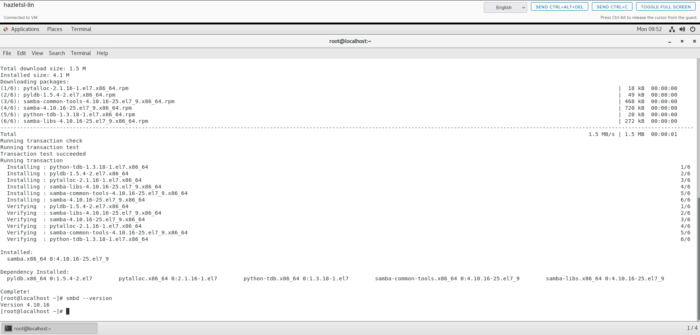

1. Samba Client

1. Maria Database

1. GCC compiler

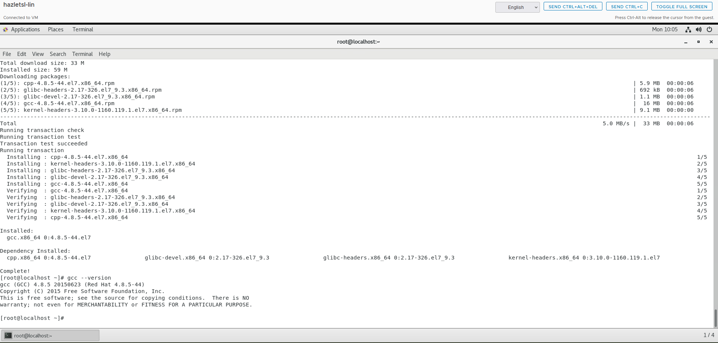

1. PHP

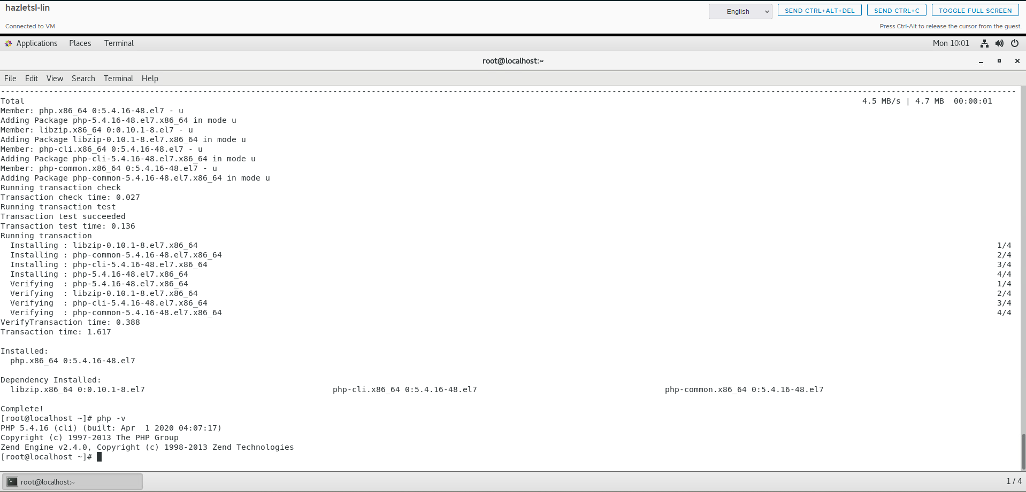

1. Python

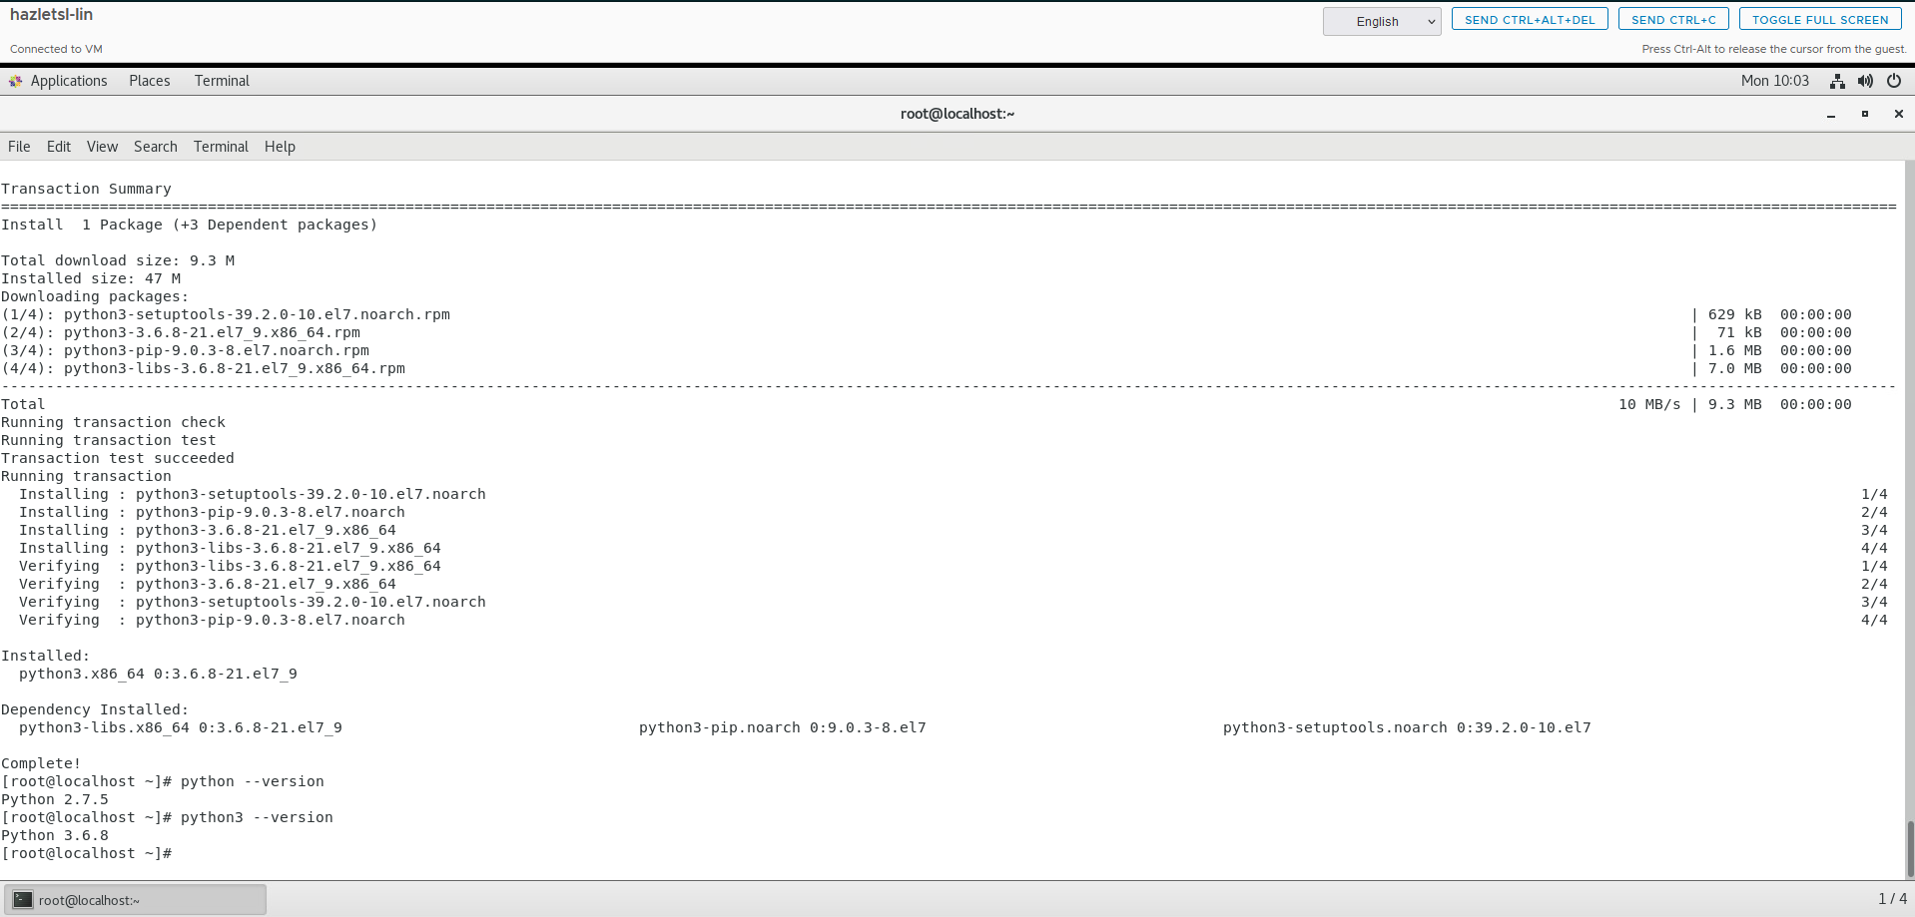

1. Paste a screen shot of ‘yum update’ showing no packages marked for update

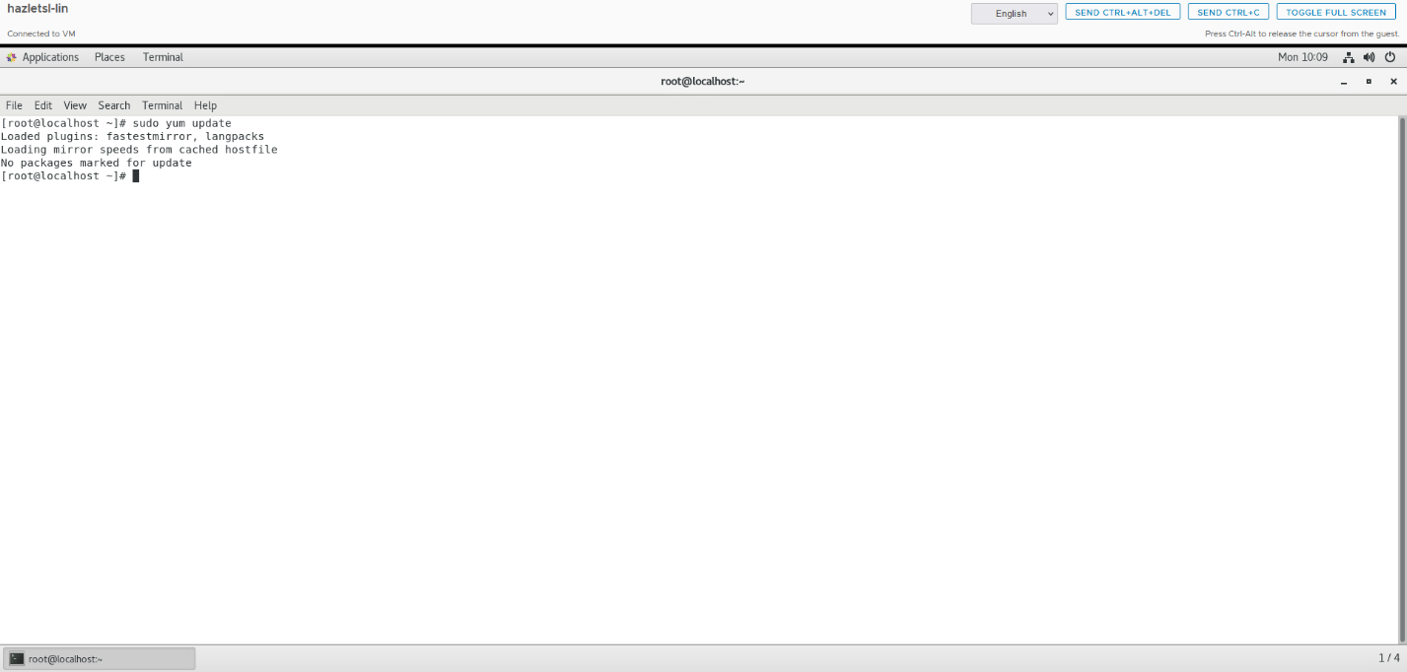

# Documentation

Record and explain all the steps you took to complete the task. Include any commands used, screen shots showing GUI interfaces, or any other information that would help you recreate the task.

**Note: You will be allowed to use this documentation to help you complete future assignments.**

Update the CentOS-Base Repo before starting lab. Ran these commands

* sudo nano CentOS-Base.repo
* cut the text out using the ctrl+k command
* went to [www.veeble.org/kb/centos-repo-list-working-urls/](http://www.veeble.org/kb/centos-repo-list-working-urls/) went over to the centos 7 section and copied the text into the CentOS-Base.repo file and save using ctrl+o then enter.
* updated the system packages to ensure everything was current. I ran the following command:
* sudo yum update -y
* I installed the Apache web server (HTTPD) using the following command:
* sudo yum install httpd -y
* verified the version of Apache with:
* httpd -v
* installed Samba, which provides file and print services for SMB/CIFS clients, by executing
* sudo yum install samba -y
* checked the Samba version using:
* smbd –version
* Samba client, I used the following command:
* sudo yum install samba-client -y
* verified version by using:
* smbclient –version
* installed MariaDB with the command:
* sudo yum install mariadb-server -y
* verified version by using the command:
* mysql –version
* installed gcc by running the following command:
* sudo yum install gcc -y
* verified gcc by running this command:
* gcc –version
* installed PHP, I ran the command:
* sudo yum install php -y
* verified the install using command:
* php -v
* installed Python 3 with the command:
* sudo yum install python3 -y
* verified install running this command:
* python3 –version
* after installing the requested software, I executed:
* sudo yum update -y
* output confirmed was:
* No packages marked for update